ELECTRONIC PAYMENTS
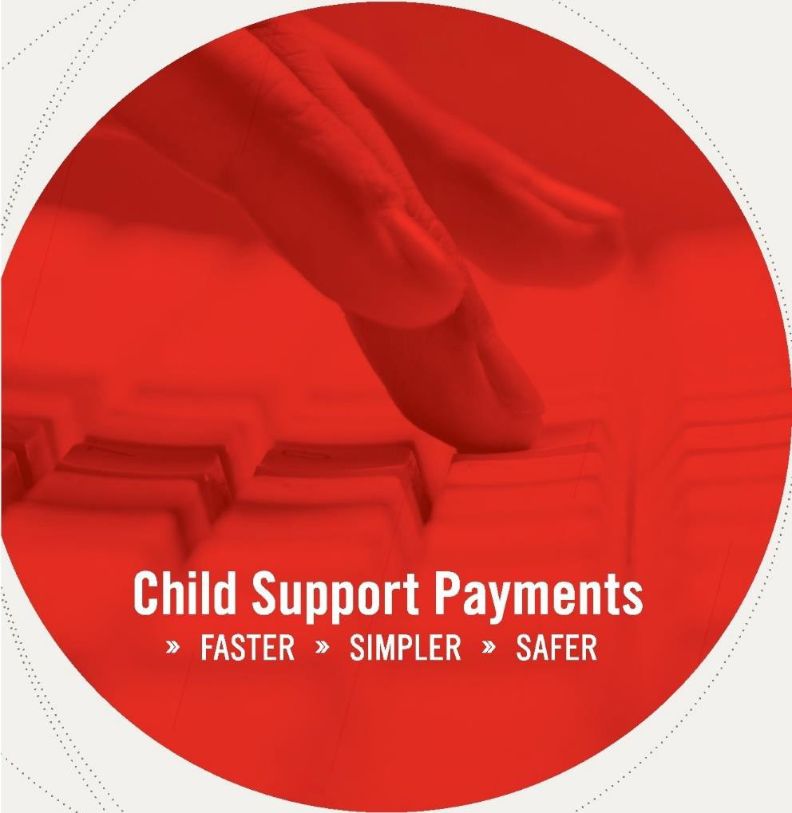

REDUCE PAPERWORK
ENSURE ACCURACY
PROVIDE SECURITY
DECREASE COST
SAVE TIME

SIGN UP TODAY

» FASTER » SIMPLER » SAFER our updated, step-by-step guide to the most efﬁcient and cost-effective way for employers to remit child support withholding payments. This booklet outlines new legal requirements for electronic payments and details the easy-to-follow process of using ExpertPay or Electronic Funds Transfer to comply. Illustrated examples and contact information to answer any questions are included.

Table of Contents
Louisiana Centralized Collections Processing Unit 4
ExpertPay℠ 5
Employer Registration For ExpertPay℠ 5
Options Available Within The Website: 6
Edit Primary User 7
Manage Users 7
Change Password 7
Bank Accounts, Credit Cards, and Bank Account Verification 7
Pay By Bank 7
Bank Account Verification 8
Pay By Credit Card 8
Payment Groups 8
How to manually create a Payment Group (Method #1) 9
How To Automatically Upload A Payment Profile (Method #2) 10
Payment Center 10
Reports Menu 12
Costs 13
Fees 13
Return Fee 14
Nonsufficient Funds Fee (NSF) 14
Reversal Fee 14
Payment Reversal/Stop Payment Provision 14
Electronic Funds Transfer (EFT) 15
Certification Process 15
Registration 15
Data Cleanup 15
Completion 16
EFT Record Formats 16
Child Support Application Banking Convention 18
DED Child Support Segment/Convention 19
Sample Louisiana DED Segment 19
Element Definitions 19
Sample CCD+ File & CTX File 21
Glossary 21
EFT Registration Form 24

Louisiana Centralized Collections Processing Unit (LACCPU)

In 1975, Title IV-D of the Social Security Act was amended to establish the Federal Child Support Enforcement Program. Under the law, states are allowed to set up their own child support programs to locate non-custodial parents, establish paternity and support, and collect and disburse support payments.

The Personal Responsibility and Work Opportunity Act (PRWORA) of 1996 required that all states develop a centralized collection and disbursement program in order to further strengthen the child support program. The Louisiana Centralized Collections Processing Unit (SDU) provides employers the opportunity to electronically remit support payments to one central location for all cases in the State of Louisiana.

- Accuracy – Before you submit electronic payments, Louisiana Centralized Collections Processing Unit verifies employer and employee data to ensure that payments are properly identified. Thereafter, employee information is merely confirmed during each payroll cycle, not re-entered, which eliminates costly errors.

- Economy – save staff time. There are no checks to print. No labels. No envelopes. No postage.

- Convenience – Electronic payments require only one transaction per pay period – whether ExpertPay℠ or Electronic Funds Transfer (EFT). Just review your last submission and update the information as necessary.

- Security – Good fiscal practice: One person at your company can confirm employee information, and another person can authorize the payment transaction.

Remitting child support payments electronically eliminates the recurring time and expense of preparing lists of employee remittance information for each payroll and mailing that data with paper checks. This process also eliminates the recurring postage costs. Because the remittance information is transmitted electronically and is not entered by hand, the opportunity for payment application errors is greatly diminished.
Employers who remit child support payments to the Louisiana Centralized Collections Processing Unit have the flexibility of choosing between two electronic payment methods:

- ExpertPay℠ – ExpertPay℠ is an innovative Web-based solution found at www.expertpay.com. ExpertPay℠ allows employers to manage every aspect of the payment process with the click of a mouse. ExpertPay℠ is transaction FREE to those employers who remit child support payments to the Louisiana Centralized Collections Processing Unit via ACH Debit.

- Electronic Funds Transfer (EFT) – By using Electronic Fund Transfer (EFT) employers can send payments electronically through their own financial institution, which will originate an ACH (Automated Clearing House) credit transaction to the Louisiana Centralized Collections Processing Unit. Employers should check with their financial institution to make sure they offer an ACH Credit origination service and that they are eligible to use this service. Employers should also ask about fees, capabilities, and deadlines.

ExpertPay℠

We are happy to offer employers who send payments to the Louisiana Centralized Collections Processing Unit a Transaction Free Option using ACH Debit to remit payments electronically. There is a one-time registration fee of $2.50. We hope that you will find ExpertPay℠ a useful tool in the child support payment process.

It is our goal to provide our customers with a website that minimizes the effort of remitting child support payments. However, if at any time you have a question or concern about ExpertPay℠, please feel free to call ExpertPay Customer Service at 1-800-403-0879 Monday - Friday 8 a.m. to 8 p.m. EST, or email customer.service@expertpay.com.

Employers may utilize ExpertPay℠ to remit all their child support payments to every State. However, there are fees for some States. If you have questions regarding fees for payments remitted to other states, visit www.expertpay.com/employerapp/#/fee , and click on “Fees” at the bottom of the page. The following is a step-by-step guide to accessing, registering and using ExpertPay℠ for employers.

Employer Registration For ExpertPay℠
If you are new to ExpertPay℠, click on the “Register Now” button on the ExpertPay℠ at www.expertpay.com.

This will bring you to the registration screen shown below.

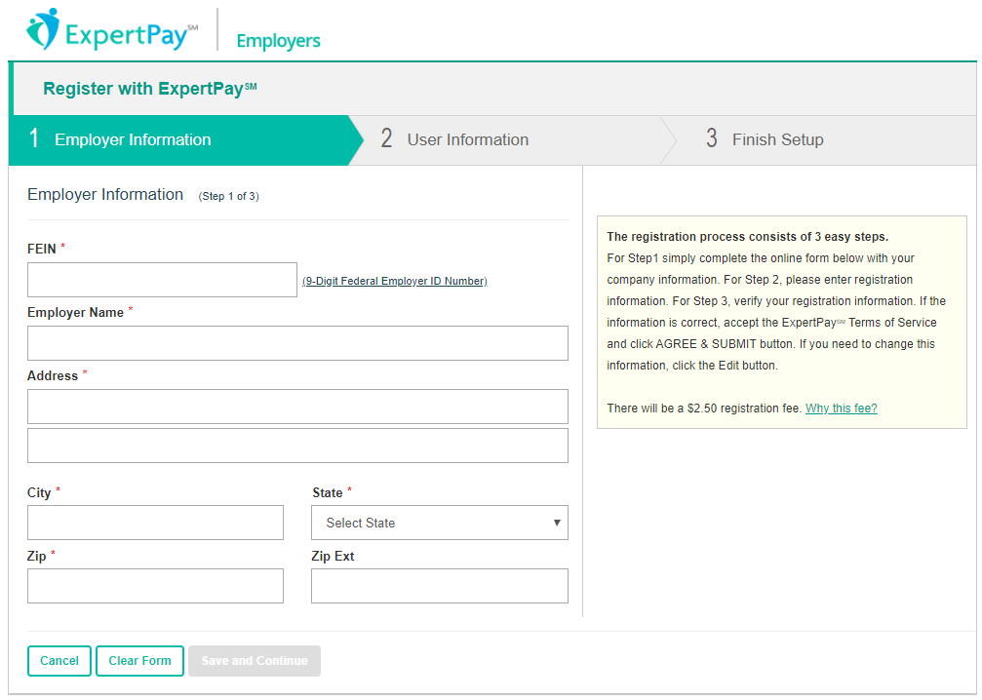

Once you have entered the necessary information, click on “Save and Continue”. Next: add the Primary User information and create your User ID which will be used every time you log into your ExpertPay℠ account. After verifying the information, click “Save and Continue”. This takes you to the Finish Setup page. Verify the entered information and click the “I have read and accept the Terms of Service” box. You must then click on this box in order for your account to be registered. After clicking “I have read and accept the Terms of Service” box, click “Agree and Submit”. An email will be sent containing your ExpertPay℠ account number and password. Do not use your account number as your User ID.

Your email confirmation containing your account number and password will also provide a link to get back to the ExpertPay℠ website. You can then enter your user ID and password to enter ExpertPay℠. ExpertPay℠ will force you to change your password the first time you log in. If you ever forget your password, a new password can be obtained by entering your user name in the “Forgot your password?” link on the login page. After you have successfully signed in, the Payment Center page (the home page for employers) will then be displayed. The options listed in the menu bar allow employers to enter, edit, and/or delete information and complete payment transactions.

Options Available Within The Website:
Once you have registered for ExpertPay℠, there are three basic steps to complete in order to make your first payment.

- The first time you log in, you will be required to change your password

- Before you can make a payment, details about your bank account and/or credit card and employees for whom child support payments will be withheld need to be entered into the ExpertPay℠ system. Instructions on how to complete this step can be found below in the “Payment Method” and “Payment Group” tabs.

- To make a child support payment on behalf of your employees, access the Payment Center in ExpertPay℠.

Note: Under the “Welcome” drop down in the top right corner of the page, there are four options
- Edit Primary User
- Manage Users
- Change Password
- Log Out

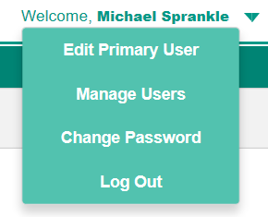

Edit Primary User
This option allows the primary user to edit the Primary User. The primary user is the individual who will have the ability to add/delete bank accounts and add secondary users in ExpertPay℠. The primary user can be changed at any time by clicking on “Edit Primary User” or calling Customer Service at 1-800-403-0879.

Manage Users
To add, edit, or delete Secondary Users, The primary user will select “Manage Users” from the drop down next to the user’s name in the top right of the screen. The Primary User has the ability to limit the actions of the Secondary Users on the website, by adjusting the options under “User Permissions” on the Employer User Permissions Detail screen.

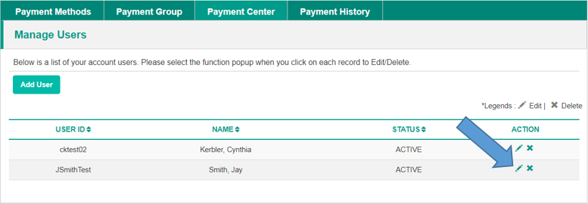

Change Password
This option allows you to change your assigned password at any time to a personalized password. Type the old password; next, type the new password you have chosen; then type the new password again to confirm it.

Bank Accounts, Credit Cards, and Bank Account Verification
Under the Payment Method tab, the employer has two available options for payment. “Pay by Bank” or “Pay by Credit Card”. Navigate to the bank account list by clicking “Payment Methods” from the menu bar.

Pay By Bank
For transaction free payments select “Pay By Bank”. Enter the routing, account number, and account type from which the support payments will be debited and click “Save and Complete”. A message will display stating: “Your bank account setup was successful. In order to verify that you are an authorized account user, a small transaction will be sent to the bank account overnight. Once you see the transaction in your bank account, you must log in to ExpertPay℠ within three business days to verify the transaction information. Once this step has been successfully completed, you will have the ability to submit your child support payments through ExpertPay℠.

All new and edited bank accounts (where the routing transit and/or account number has been changed) must go through Bank Account Verification.

Bank Account Verification
Your bank account list will show the “Verify” button in the Action Column:

Click on the “Verify” button to go to the Bank Account Validation screen where you need to enter the transaction amount.

If you have more than one bank account, additional accounts can be added by clicking “New Bank Account” and repeating the process.

Pay By Credit Card
For transactions made by credit card, select “Pay By Credit Card”. Enter the credit card information (i.e. Name on the Account, Credit Card Number, Expiration Date, and Card Security Code). Enter the user billing information (i.e. First Name, Middle Initial, Last Name, Country and address) and click “Save Changes”. A message will appear stating “Credit Card details have been added successfully”

Payment Groups
Payment Groups are used to create and submit employee case payments on a regular basis. It is a list that you create to store payment information for a group of your employees who are subject to withholding orders. You can have as many groups as you want. Examples of possible payment group names are weekly, monthly, salaried, eastern division, western division or whatever name you want to give the group.

There are two methods to create a Payment Group with ExpertPay.

Method # 1: Create a Payment Group manually by logging into the ExpertPay website, creating a group, and manually inputting the case information for each employee. This is a list that you create to store payment information for a group of your employees who are subject to withholding orders.

Method #2: Create a Payment Group automatically by uploading a file. This service can save valuable time, as your employees' electronic payment information is sent directly to the secure ExpertPay website. You do not have to type in each employee’s withholding data for each payment. Employers who make repeat payments for a large number of employees will find that the Payment Group Upload function will help improve the overall payment process.

How to manually create a Payment Group (Method #1)
- Click Payment Groups on the menu bar.
- Click Add profile box.
- Type in the name of the profile in the box next to payment group name
- Select the bank account.
  - Click on the down-arrow to the right of the box.
  - Click on the desired bank account.
- Click Add Employee.
- Enter Employee Withholding information

Enter the appropriate employee information and click “Save and Add Employee.” Add additional employees or Save and Complete the payment group.

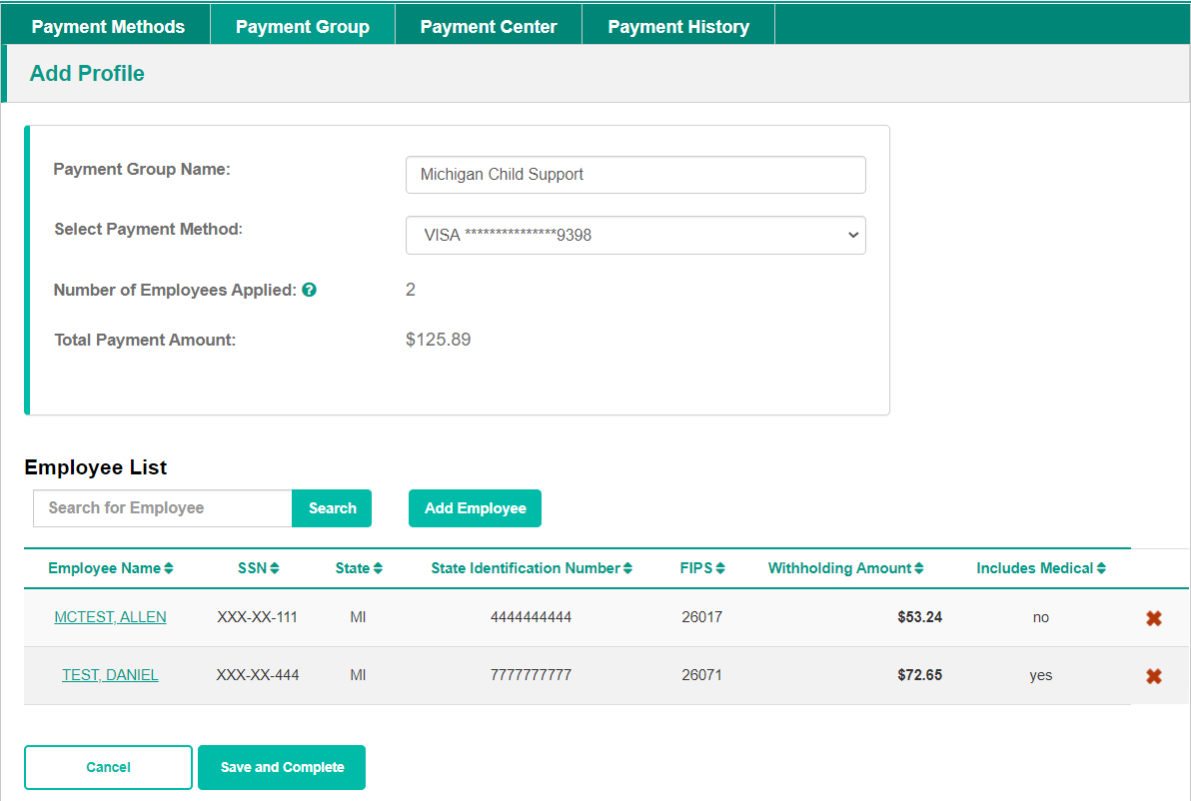

Once you click save and complete, your profile will be listed

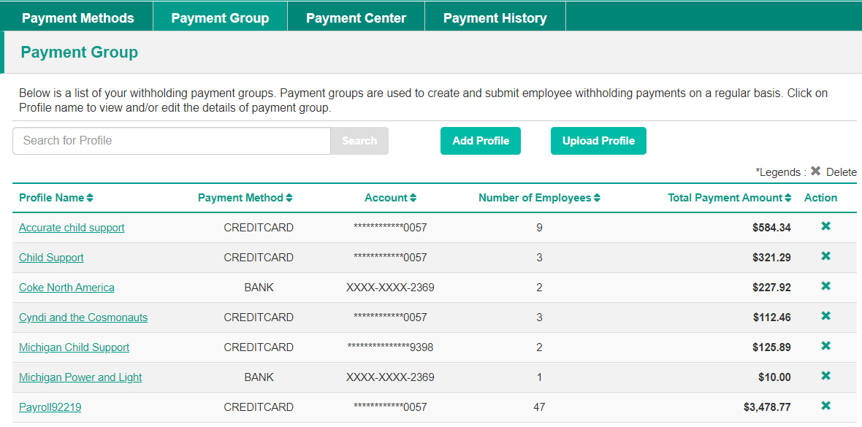

How To Automatically Upload A Payment Profile (Method #2)
If you remit child support payments for many employees, ExpertPay℠ provides you with the ability to upload a Payment Profile. For more information on this time-saving option, click “Help” on the ExpertPay℠ website. On the left side of the screen, choose “Download User Manual” and go to “Profile Upload Overview”.

Payment Center
After logging into ExpertPay℠, click on “Payment Center” and the following screen will appear:

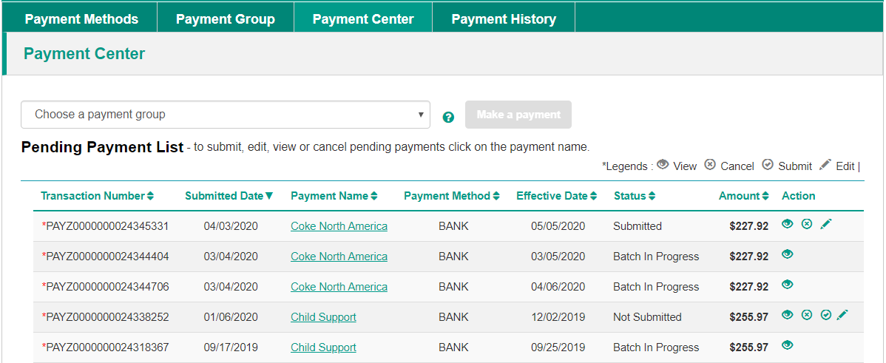

On this screen you must first choose your payment group by clicking on the drop box arrow. Click “Make a payment” after verifying the information click "Continue". You will then need to complete the following steps.

  - Verify the bank account to be debited
  - Select an effective date (the date on which ExpertPay will debit money from your bank account
  - Select a withholding date(the date you deduct money from the employee)
  - Submit payment

Completing these steps will return you to the payment receipt screen.

Also located on the Payment Center screen is a payment list. The payment list is a list of child support withholdings created by using the above payment profile categories. ACH Payments in this list can be edited or cancelled prior to 8:00 PM EST by left clicking on the mouse and selecting the appropriate action. Credit Card payments must be cancelled prior to 6:00 PM EST. In the Payment Center you may make changes to your list of employees. However, making changes on this screen will not edit the employee’s information permanently.
For Example: if you delete an employee from the list due to termination or no deduction the employee will reappear on the list during the next payroll cycle. In order to permanently delete an employee, you will need to update the employee’s information on the “Payment Group” screen.

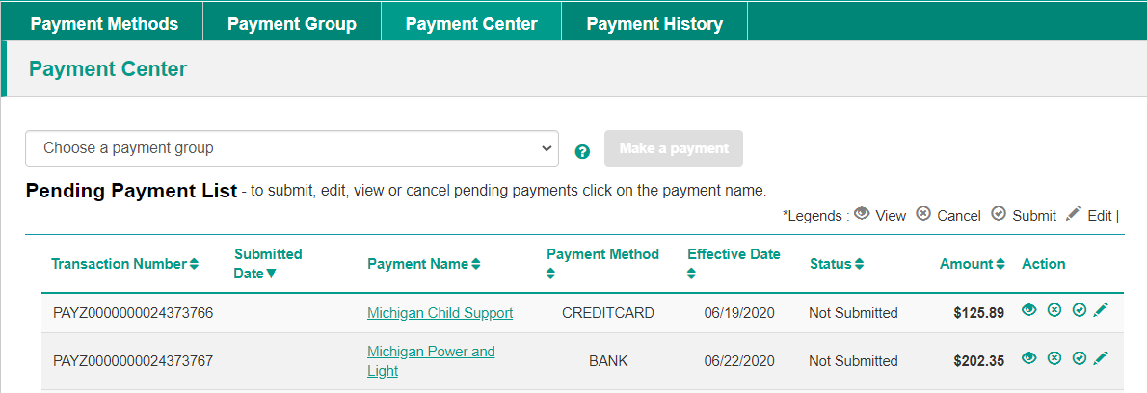

In the example above, the payments are in the not “Not Submitted” status. For payments submitted by bank account, payments submitted after 8 PM EST will be processed on the next business day. Payments may be edited or cancelled until 8 PM EST on the day it is entered. For payments made by credit card or PayPal, payments can be cancelled until 6:00 PM EST. You must contact ExpertPay℠ Customer Service at1-800-403-0879 to report any errors. ExpertPay℠ is not responsible or liable for errors made when entering payment information.

Reports Menu
The Payment History screen contains links to two reports that may be helpful to you:

  - Payment Transaction Report
  - Employee Transaction Report

To view the reports, enter the date range in which the transaction took place and click “Retrieve.” For the Employee Payment History Report you will also need to enter the employee’s Social Security Number.

Costs
Employers who remit ACH payments to the Louisiana Centralized Collections Processing Unit will not be charged transaction fees for those remittances. There may be a cost to remit child support payments to other states. If you have any questions regarding fees charged for remittances to other states, please click on the Fee link please contact ExpertPaySM Customer Service at 1-800-403-0879.

The information below appears in the Terms of Service Agreement:

Fees
There is one-time registration fee of $2.50 that will be deducted from your account upon submission of your first company's payment. This registration fee is charged only once, no matter the number of remittances associated with the payment. This registration is not tied to any transaction fees. For example, if you are not charged a transaction fee for each payment, you will still need to pay the one time registration fee. If you register your company more than one time, each registration is subject to the registration fee upon submission of your first payment made using the new registered account.

In some states other than Louisiana, there is a transaction fee per employee remittance that will be assessed to your account for each submitted payment. If you have an employee with multiple cases, each subsequent employee remittance with the other case information will be charged this transaction fee. You should also contact your bank or credit card provider regarding potential processing fees. Remittances to some states are offered at rates other than our standard rate. Please review the fee section on the web site to obtain more information regarding transaction fees.

ExpertPay℠ receives payment information from employers and debits employer bank accounts to offset the cumulative payment transactions. All payments are forwarded to the government agency in a state the day funds are available. In effect, ExpertPay℠ acts as a clearing and distribution system that permits an employer to interact with many states from a single web site. Fees are charged to an employer for returned items and these fees are recovered through ACH debit to the employer's bank account. There are three types of return fees - fees for providing incorrect banking information, fees for returned debits due to Non-sufficient funds and fees for employer initiated reversals.

Return Fee
Any payment submitted by you that is returned to ExpertPay℠ due to incorrect payment method information supplied by you on your member account will result in a $20.00 fee. This fee will be assessed to your updated account prior to any future use of the service. The payments that were originally submitted and resulted in the return will be stopped and must be re-submitted by you.

Nonsufficient Funds Fee (NSF)
Any payment submitted using a bank account that is returned to ExpertPay℠ for non-sufficient funds will result in a $50.00 NSF fee. This fee will be assessed to your account prior to any future use of the service. The payments that were originally submitted but resulted in the NSF will be stopped and must be re-submitted by you. When you submit payments using a bank account, an ACH debit is sent to your account(s) to withdraw the funds. The funds will then show as being received in our account and withdrawn from your account on the "settlement date". However, if your account did not have the funds to cover the ExpertPay℠ debit amount, then your Bank will notify ExpertPay℠ within two (2) days that the payment was NSF, and our account is debited. As a precaution, ExpertPay℠ holds all funds until we are confident that the funds have cleared your Bank. We then send the funds to the appropriate state child support agency. If an NSF notice is received, we will cancel your original payment, and assess your account the $50.00 fee. Note, this is in addition to any fees your own Bank may charge.

Reversal Fee
Any payment submitted by you that is requested to be 'stopped' from being sent, due to an error on your part, will result in a $20.00 charge for each payment record that was stopped. The fees will be debited from your account. Extenuating circumstances will be acknowledged as indicated in the following section.

Payment Reversal/Stop Payment Provision
Member/Company agrees to honor all payments originated using ExpertPay℠, and shall not request ExpertPay℠, member's bank, or member's credit card provider to reverse any ExpertPay℠ debits or payment(s), unless payment(s) wishing to be reversed/stopped were:
- Fraudulently made; OR
- Duplicates of previous payments submitted to ExpertPay℠ the same day in error; OR
- Other circumstances subject to ExpertPay℠ approval, at ExpertPay℠ sole discretion; AND, Member notified ExpertPay℠ by payment cutoff time, on the day following the settlement date of the payment wishing to be reversed/stopped.

Electronic Funds Transfer (EFT)

This section is not applicable to employers who submit payments via ExpertPay℠.

To begin submitting payments via Electronic Funds Transfer (EFT), it is necessary to choose the method your company wishes to use to submit payments, and then coordinate with your payroll office, technical staff, and your financial institution. In order to transmit child support payments using EFT, you must be able to generate a file that can be transmitted to your bank. Your bank should be able to guide you as to how to submit electronic payment information to them. Development of this electronic processing capability can be accomplished “in-house” by your own technical staff, through software provided by your bank, or by using commercial-off-the-shelf (COTS) software. Your bank must then be able to transmit the file, including the addenda records, through the Automated Clearing House (ACH).

The ACH releases the file on the appointed date to the SDU bank, JP Morgan Chase, which forwards the file information, including the addenda records, to the Louisiana Centralized Collections Processing Unit.

Before remitting your first EFT file to the Louisiana Centralized Collections Processing Unit, please copy and submit the Employer Registration form provided at the end of this booklet.

Certification Process
We have established a certification process to help you prepare for your initial EFT submission. The certification process consists of two major components:
- Completed registration form so the Louisiana Centralized Collections Processing Unit has good contact information should there be any issues with processing the EFT file.
- Data Cleanup ensures that the data is complete and accurate so payments are not delayed or do not require manual intervention at the Louisiana Centralized Collections Processing Unit.

Registration
Please complete and return the employer registration form at the end of this booklet so the Louisiana Centralized Collections Processing Unit has good contact information in the event there are issues processing your file.

Data Cleanup
To ensure a smooth transition to EFT, it is important that the information submitted with your file is correct. We will ask that you fax or email us a copy of the list you are currently sending with your payment to the LA Centralized Collections Processing Unit. We will then validate the information against the Louisiana Child Support Enforcement System (LASES). The verification will include the following items:
- LASES: Case Number: up to 11 characters.
AND
- Social Security Number (SSN): The non-custodial parent’s unique identification number.

Once we have validated the information, we will notify you of any changes that must be made. The Louisiana Centralized Collections Processing Unit email address is LAEFT@Coduent.com.

Completion
It is not necessary to go through the certification process each time a new employee is added to your withholding list provided the complete and accurate information for that payment is included in your addenda record. If you are not sure whether the new information is complete and correct, contact the Louisiana Centralized Collections Processing Unit Customer Support at 1-225-924-5990 and follow the prompts to be connected to EFT outreach representative.

EFT Record Formats
The rules and guidelines governing the formats, specifications and exchange of ACH entries are published by NACHA, the Electronic Payments Association. With respect to the data that are contained in the addenda records of ACH formats, the NACHA Operating Rules stipulate the type of data that may be exchanged as well as which standards and formats are permitted, but the structure of the data contained therein is managed outside the NACHA rules. For example, the NACHA Operating Rules permit the exchange of certain EDI messages or transaction sets (e.g., 820 Payment Order/Remittance Advice) within the Addenda Records of the CTX format, but those standards are developed and maintained by other standards development organizations, such as ASC X12 and UN/EDIFACT. While this information may be confusing, simply view this electronic record as the same information provided on a check and the remit which contains posting instructions, but just in an electronic format or language.

The following record formats are used to convey entries through the ACH Network:
- File Header Record (the 1 record)
- Company/Batch Header Record (the 5 record)
- Entry Detail Record (the 6 record)
- Addenda Record (the 7 record)
- Company/Batch Control Record (the 8 record)
- File Control Record (the 9 record)

An ACH file is bounded by one File Header Record and one File Control Record, which serve to facilitate transmission, identification and balancing of the file. A file may be comprised of one or more batches, which are denoted by the Company/Batch Header Record and Company/ Batch Control Record. These records contain information specific to all of the Entry Detail Records contained within that batch. A batch may house one or more Entry Detail Records that share certain aspects as explained in the NACHA Operating Rules. The Entry Detail Record is the record that constitutes the payment order and is used within the banking system to execute EFT and settlement. An Addenda Record is used to supply additional payment related information related to the payment issued in the Entry Detail Record. Each Addenda Record includes an 80 position Payment Related Information Field within which this remittance detail is transmitted.

The CCD and CTX payment formats are used within the ACH Network to conduct the transfer of funds between business or government entities. To exchange data along with payments using EDI technology, Addenda Records are used. Under the NACHA Operating Rules, a CCD format may be accompanied by only one Addenda Record, which may carry X12 data segments or elements or NACHA- endorsed banking conventions. A CCD entry accompanied by an Addenda Record is referred to as a CCD+. The CTX format allows for the provision of 9,999 Addenda Records, which must carry a full X12 transaction set or UN/EDIFACT message (the transaction set or message must be format- ted correctly – including the batch information and in the case of the ASC X12 820, both Table 1 and Table 2).

The NACHA record formats for CCD+ entries flow in the following order:

File Header Record
Company/Batch Header Record
Entry Detail Record
Addenda Record (1 addenda with 80 byte Payment Related Information Field)
Entry Detail Record
Addenda Record (1 addenda with 80 byte Payment Related Information Field)
Entry Detail Record
Addenda Record (1 addenda with 80 byte Payment Related Information Field)
Entry Detail Record
Addenda Record (1 addenda with 80 byte Payment Related Information Field)
Company/Batch Control Record
File Control Record

The NACHA record formats for CTX entries flow in the following order: Please remember that the CTX must contain a fully formatted ASC 820 transaction set – which includes all batches, the Table 1, and Table 2 which can contain multiple DED loops. The syntactically correct ASC 820 is then broken into 80 byte segments embedded in the CTX 07 addenda records.

The NACHA record formats for CTX entries flow in the following order:

File Header Record
Company/Batch Header Record
Entry Detail Record
Addenda Record (up to 9,999 addenda with 80 byte Payment Related Information Field)
Addenda Record
Addenda Record
Addenda Record
Addenda Record
Addenda Record
Addenda Record
Addenda Record
Addenda Record
Addenda Record
Company/Batch Control Record
File Control Record

Child Support Application Banking Convention
Within the 80 position Payment Related Information Field of the CCD+ Addenda Record, remittance information corresponding to the child support payment made by an employer to an SDU is presented in the following banking convention. This convention is referred to as the ‘DED’ Deduction data segment under ASC X12 syntax and is composed of ten fields:
- Segment Identifier
- Application Identifier
- Case Identifier
- Pay Date
- Payment Amount
- Non-Custodial Parent Social Security Number
- Medical Support Indicator
- Non-Custodial Parent Name
- FIPS Code
- Employment Termination Indicator

Each field is referred to as a data element, which is the smallest named item in a record. It can represent a qualifier, a value, or text. A data element has three primary attributes – length, field requirement, and type. Each data element is identified by an element identifier used for reference (e.g., DED01, DED02, etc.), and each element has a specific position within the record (segment). In constructing the segment, each data element is preceded by the separator character. In the ACH, the data element separator is an asterisk (‘*’). Each segment must end with a terminator, which in the ACH is a backslash (‘\’).

The following is an example of the DED segment as used in the Payment Related Information field of the CCD+ Addenda Record:

DED*application identifier*case identifier*paydate*payment amount*non-custodial parent ssn*medical support indicator*non-custodial parent name*FIPS code*employment termination indicator\

Note the use of the asterisk (‘*’) and backslash (‘\’).

Data elements in a segment are either mandatory or optional. Data elements in a segment that are not mandatory as defined by the standard may be omitted. The omission of an optional element is noted by the placement of an asterisk in the place of that element. For example, if
non-custodial parent name were to be omitted from the segment, it would look like this:

DED*application identifier*case identifier*paydate*payment amount*non-custodial parent ssn*medical support indicator*FIPS code*employment termination indicator\

Also, if an optional data element is the last data element in a segment and that field is not being used, the preceding asterisk is replaced by the backslash. For example, if the employment termination indicator is omitted from the segment, it would look like this:

DED*application identifier*case identifier*pay date*payment amount*non-custodial parent ssn*medical support indicator*non-custodial parent name*FIPS code\

DED Child Support Segment/Convention

The following grid delineates the format for the DED Segment/Convention for employers:

Element | Comments | Content | Attributes
 |  |  | 1 | 2 | 3
 | Segment Identifier | DED | M | ID | 3/3
DED01 | Application Identifier | CS | M | ID | 2/2
DED02 | Case Identifier (Louisiana Docket Number) | 1XXXXXXXXX | M | AN | 1/20
DED03 | Pay Date | YYMMDD | M | DT | 6/6
DED04 | Payment Amount | $$$$$$$$CC | M | N2 | 1/10
DED05 | Non-Custodial Parent Social Security Number | XXXXXXXXX | M | AN | 9/9
DED06 | Medical Support Indicator | ‘Y’ = Yes, ‘N’ = No | M | AN | 1/1
DED07 | Non-Custodial Parent Name | XXXXXXXXXX | O | AN | 1/10
DED08 | FIPS Code | 26XXXXX | O | AN | 5/7
DED09 | Employment Termination Indicator | ‘Y’ = Yes | O | AN | 1/1

Sample Louisiana DED Segment

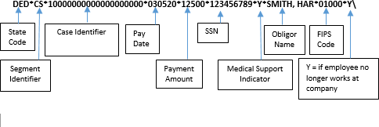
(Reminder: due to the one-addenda limitation of the CCD+ format, the DED segment is restricted to a maximum of 80 characters. Note the use of the asterisk and backslash.)

Element Definitions
DED01 Application Identifier: Supported Code Value – ‘CS’ – Child Support
The application identifier indicates the type of deduction being withheld from an employee’s pay. If you are an employer withholding child support from an employee’s paycheck, use CS as the application identifier.

DED02 Case Identifier:
The case identifier element is the State of Louisiana case number assigned to the non-custodial parent. It is 10-digit docket number and can be found on the non-custodial parent’s Income Withholding Order. For situations where the case and order number are greater than the allotted 20 characters, reverse the order and begin with the order number followed by the case number.

DED03 Pay Date:
The pay date element is the non-custodial parent’s (non-custodial parent’s) pay date or the date the payment was withheld from the employee’s paycheck.

DED04 Payment Amount:
The payment amount element indicates the non-custodial parent’s child support withheld for the current pay period, which is being paid to the Louisiana Centralized Collections Processing Unit.

DED05 Non-Custodial Parent Social Security Number: The non-custodial parent’s Social Security number element provides Louisiana Centralized Collections Processing Unit with the non-custodial parent’s Social Security number.

DED06 Medical Support Indicator:
Supported Code Values – ‘Y,’ ‘N’. The medical support indicator indicates whether the employer offers family medical insurance coverage. If medical insurance coverage is available, a ‘Y’ is placed in the field; if there is no coverage available, an ‘N’ is placed in the field.

DED07 Non-Custodial Parent Name:
The non-custodial parent’s name element indicates the first seven letters of the non-custodial parent’s last name followed by the first three letters of his/her first name.
A comma must be used to separate the last name from the first name of the non-custodial parent when the last name is less than seven characters. This field is not case-sensitive, i.e., mixed case letters are acceptable.

Example:
SMITH,JOHN (John Smith – the last name is less than seven letters long)
PENDLETJOH (John Pendleton – the last name has more than seven letters)

DED08 FIPS Code:
The Federal Information Process Standard (FIPS) code refers to the FIPS Code of the SDU receiving the transaction. It is 5 characters when indicating both the state and county codes. It is 7 characters when indicating state, county, and local codes.

DED09 Employment Termination Indicator:
Supported Code Value – ‘Y’. The employment termination indicator is used to notify the child support enforcement agency that an individual’s employment has terminated. A ‘Y’ is placed in this field if the employee has terminated; otherwise the field is not used. The payment amount field may contain zero when this field is used. If an employer’s payroll system is unable to generate the employment termination indicator, the employer is required to notify the child support enforcement agency (by phone, email or mail) when an employee with an obligation has left its employment.

Sample CCD+ File & CTX File

Sample CCD+ File

5200COMPANY NAME 1445556677CCDCHILD SUP 020301020301 1091000011229669
6220730002227007002 0000018000BROK01 STATE OF LOUISIANA 1091000011229670
705DED*CS*0000000000*020301*0000018000*999999999*W*JONSEYKEV*19000\ 00011229670
6220730002227007002 0000004476COML01 STATE OF LOUISIANA 1091000011229671
705DED*CS*0000000000*020301*0000004476*999999999*W*JOHNSONJOH*19000\ 00011229671
6220730002227007002 0000002538COML01 STATE OF LOUISIANA 1091000011229672
705DED*CS*0000000000*020301*0000002538*999999999*W*NAMELASFIR*19000\ 00011229672
820000004800000000000000000000000000000000025014004465 091000010000000

Sample CTX File, ASC X12 820 Transaction Set version 4010

5200COMPANY NAME 3005269527CTXPAYMENT 0003130731091000018186622
6220700002227007002 000011343500020877 0014COLLECTION SERVI 1021000028186652
705ISA*00* *00* *ZZ*DD90520 *01*100026753 *000508*20300018186652
7052*U*00401*000000001*0*P*>\GS*RA*005269527*100026752*000508*2032*X*004010\ST8200028186652
705*0*000000001\BPR*D*1134.35*C*DXC*CTX*01*021309379*DA*0601228265*3005269527**000038186652
7051*070000222*DA*7007002*000512*PCS\DED*CS*111111*000508*2372*333333333*N*NAMES,FIR0048186652
705*019000\DED*CS*11111*2000508*6600*333333333*N*LSTNAMEFIR*19000\DED*CS*111111*20000058186652
7050805*31250*333333333*N*LSTNAMEFIR*19000\DED*CS*111111*2000508*31731*333333333*N*00068186652
705LNAMES,FIR*19000\DED*CS*11111*2000508*5000*333333333*N*LSTNAMEFIR*19000\DED*CS*100078186652
70511111*000508*9650*333333333*N*LSTNAMEFIR*19000\DED*CS*111111*2000508*9132*33333300088186652
705333*N*LNAME,FIR*19000\DED*CS*111111*2000508*17700*333333333*N*LNAMEFIR*19000\00000098186652
70500SE*11*0001\GE*1*1\IEA*1*000000001\ 00108186652
820000001100000000000000000000000000001587763005269527 091000010000000

Glossary

Addenda Record – Also called a 7 record. Contains the information necessary to identify a payment to a specific child support case.

Attributes – A name assigned to the three data elements of the EFT attributes: element usage, element type, and minimum/maximum length.

Authentication – A mechanism which allows the receiver of an electronic transmission to verify the sender and the integrity of the content of the transmission through the use of an electronic “key” or algorithm, which is shared by the trading partners. This is sometimes referred to as an electronic signature.

Automated Clearing House (ACH) – A central clearing facility, operated by the Federal Reserve or a private sector organization on behalf of depository financial institutions (DFI) in which participating DFI’s transmit or receive ACH entries.

Beginning Segment – The first segment of data in a trans- action set. The beginning segment typically contains a segment identifier, the transaction set, and other data elements. A segment is similar to a record in a standard database application.

Cash Concentration and Disbursement/Plus (CCD) and CCD+ – A credit or debit entry initiated by an organization to consolidate funds of that organization from its branches, franchises or agents, or from other organizations, or to fund the accounts of its branches, franchises or agents, or of another organization. A CCD+ carries one addenda record with 80 characters of additional payment related information.

Corporate Trade Exchange (CTX) – A credit or debit entry initiated by an organization to effect a transfer of funds to or from the account of that organization or another organization and accompanied by remittance information. The CTX 820 is a NACHA format for use in the ACH payment system for child support payments.

Custodial Parent – The recipient of child support payments. The Custodial Parent may also be referred to as the “obligee.”

Data Conversion – The process of converting the value in a data element to an equivalent value.

Data Element – A collection of all data elements available in an EDI system. The data element defines the data type, the minimum and maximum length of the data, a reference number, and, if appropriate, a list of acceptable values.

Data Element Delimiter – A character used to separate data elements within a segment.

Data Element Length – This is the range, minimum to maximum, of the number of character positions available to represent the value of a data element. A data element may be of variable length with range from minimum to maximum, or it may be of fixed length in which the minimum is equal to the maximum.

Data Element Number – A unique reference number assigned to each data element in the data element dictionary for each EDI standard.

Data Element Requirement Designator – A code defining the need for a data element value to appear in the segment if the segment is transmitted. The codes are mandatory (M), optional (O), or relational (X).

Data Element Type – A data element maybe one of six types: numeric, decimal, identifier, string, date, or time.

Electronic Funds Transfer (EFT) – The electronic transfer of money between accounts at different banks.

Ending Segment – The segment that indicates the end of a transaction set.
FIPS Code (Federal Information Processing Standards) – For child support purposes, each state is assigned a two-digit code (Louisiana is 26) and each county within that state is alphabetically assigned a three-digit number. For example, the default FIPS code for Louisiana is 26000.

Header Segment – A segment that begins every batch and identifies the data contained in that batch. Each header contains a control number that must match the control number in the corresponding trailer.

Income Withholding – The process where in an employer or income payer holds out court-ordered child support from a non-custodial parent and in turn remits that payment to SDU for disbursement to the custodial parent.

Mandatory Data Element – An element containing information that must be present in the transaction as mandated by the standards.

Mandatory Segment – A segment containing information that must be present in the transaction as mandated by the standards.

Maximum Use – The maximum number of times a data segment can be used in specifications succession.

National Automated Clearing House Association (NACHA) – The national trade association for electronic payments associations, which establishes the rules, industry standards, and procedures governing the exchange of commercial ACH payments by depository financial institutions.

Non-Custodial Parent – The payor of child support payments. The Non-Custodial Parent may also be referred to as the “obligor.”

Office of Child Support Enforcement (OCSE) – A federal office responsible for the establishment of child support program standards and regulations applicable to all state child support programs.

Optional Data Element – A data element used in an EFT file segment that contains information not required by the standard but that can be included in the transaction at the discretion of the sender or receiver.

Optional Data Segment – A data segment used in an EFT file segment that contains information not required by the standard but that can be included in the transaction at the discretion of the sender and receiver.

Pay Date – The date a payment is withheld from an employee (non-custodial parent).
Personal Responsibility and Work Opportunity Reconciliation Act (PRWORA) – The 1996 federal law that requires all states to implement a centralized payment receipt and disbursement unit.

Proprietary Standard – An industry or company-specific data format that has been developed by a company for exchanging data with its trading partners. These proprietary formats usually do not comply with ANSI ASC X12-based standards.

Segment Identifier – A unique identifier for a segment composed of a combination of two or three uppercase letters and digits. The segment identifier occupies the first character positions of the segment. The segment identifier is not a data element.

Segment Terminator – A unique character appearing at the end of a segment to indicate the termination of the segment.

Trailer Segment – A segment that ends every batch and provides counts of the segments, transaction sets, or functional groups transmitted. Each trailer contains a control number that must match the control number in the corresponding header.

EFT Registration Form

EMPLOYER REGISTRATION FORM FOR ELECTRONIC FUNDS TRANSFER (EFT)
You Must Complete and Submit this Information before Making Your First Electronic Transmission to the Louisiana Centralized Collections Processing Unit (CCPU).

Company Name
FEIN
Contact Name
Contact Phone
Contact Fax
Contact Email
Technical Contact Name
Technical Contact Phone
Technical Contact Fax
Technical Contact Email
Signature
Date

Please Complete All Information. If you have any questions, please call theLouisiana Centralized Collections Processing Unit Customer Service at 225-924-5990, Monday through Friday, 8: AM To 4:30 PM CST.

Email, Fax, or Mail this form to:

Email: LAEFT@Conduent.com
Mail: Louisiana Centralized Collections Processing Unit PO Box 260222, Baton Rouge, LA 70826
FAX: 225-924-6443

